**Milestone 7**

* Thirsty Tracker
* Kiana Harkema, Devin Magnuson, Casey Tran, Olywn Doyle, Adam Hoerger
* Trello: <https://trello.com/b/tD9jaXv6/thirsty-tracker>

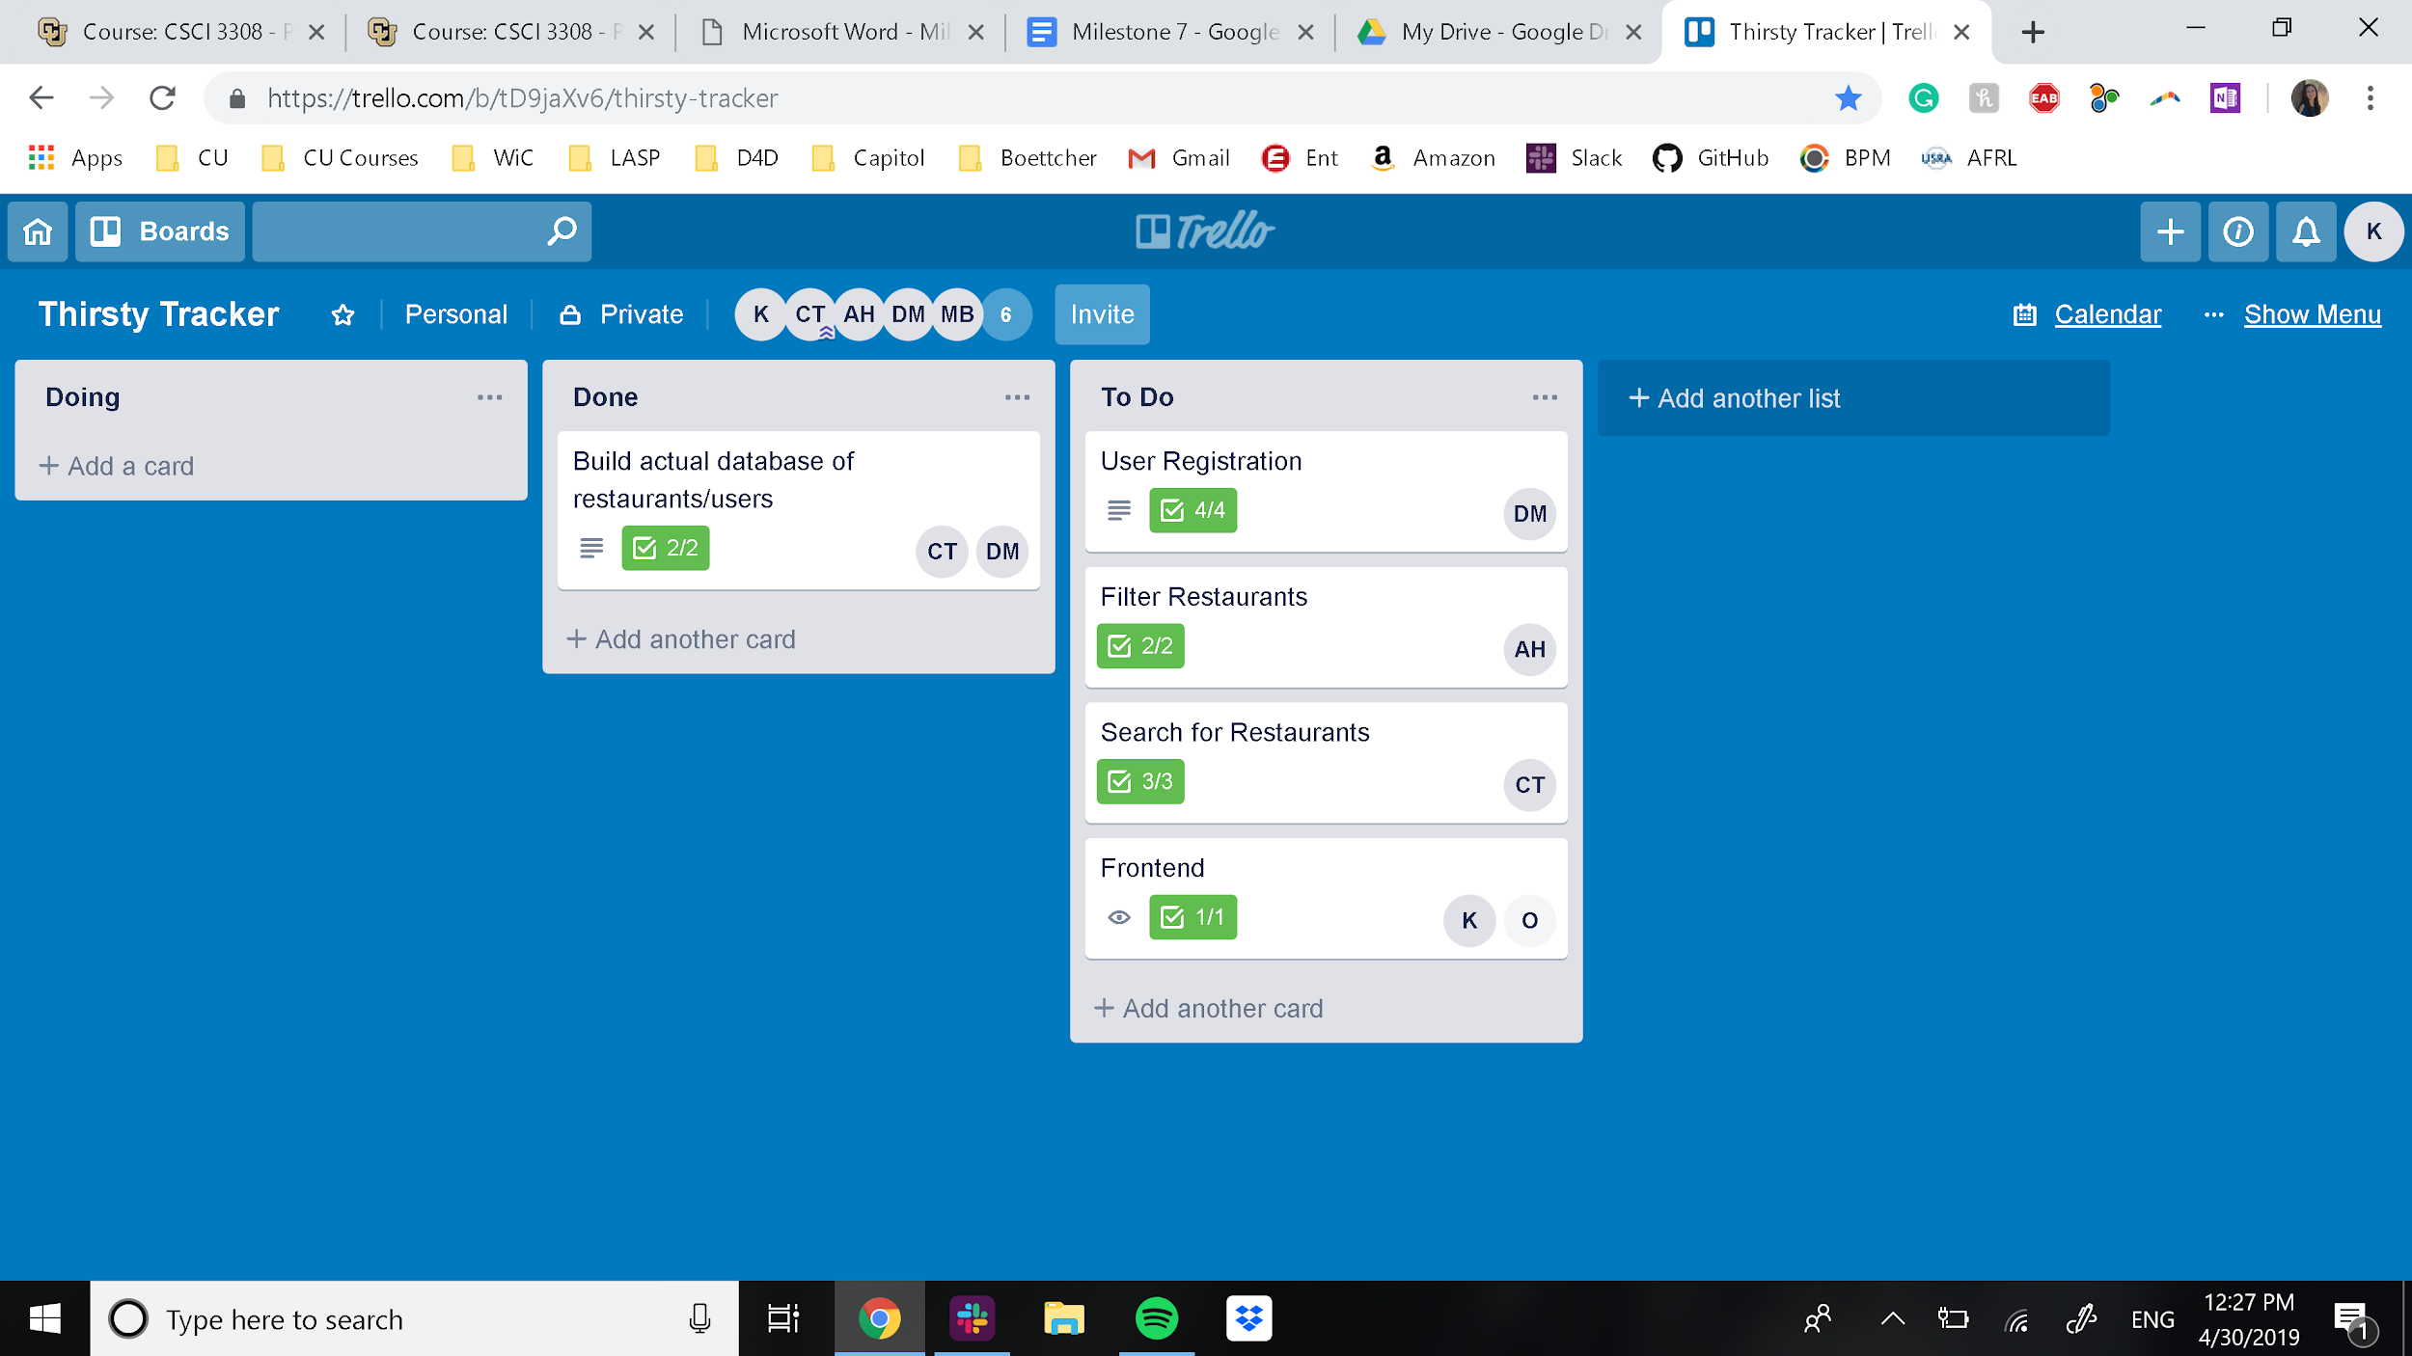

* Git:
  + Meeting notes - <https://github.com/Devinmagnuson/RNGMeetings>
  + Milestones - <https://github.com/Devinmagnuson/RNGMilestones>
  + Code - <https://github.com/Devinmagnuson/RNGCode>

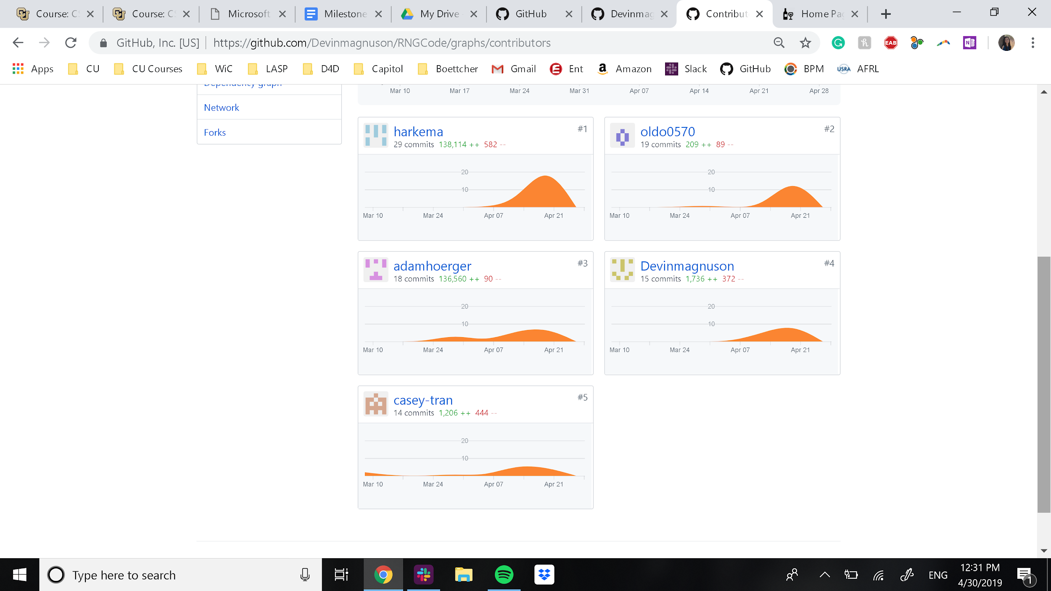

* Deployment: <http://cuthirstytracker.herokuapp.com/>